Lab # 5
IMPLEMENTATION OF GENETIC ALGORITHM 8 QUEEN PROBLEM IN PYTHON
Objective:
- To learn packages in Python
- To learn how to import package in Python
- To Implement 8 queen problem in Python
Lab related theory:
Modules and Packages in Python
A module allows you to logically organize your Python code. Grouping related code into a module makes the code easier to understand and use. A module is a Python object with arbitrarily named attributes that you can bind and reference.
Simply, a module is a file consisting of Python code. A module can define functions, classes and variables. A module can also include runnable code.
Here's an example of a simple module, mymodule.py
def print_func( par ):
print "Hello : ", par
return

The import Statement

You can use any Python source file as a module by executing an import statement in some other Python source file. The import has the following syntax:
import module1[, module2[,... moduleN]

When the interpreter encounters an import statement, it imports the module if the module is present in the search path. A search path is a list of directories that the interpreter searches before importing a module. For example, to import the module mymodule.py, you need to put the following command at the top of the script –
#!/usr/bin/python
# Import module support
import mymodule
# Now you can call defined function that module as follows
support.print_func("AI Student")

Built in packages:

To use any package in your code, you must first make it accessible. You have to import it. You can't use anything in Python before it is defined. Some things are built in, for example the basic types (like int, float, etc) can be used whenever you want. But most things you will want to do will need a little more than that.

Type :

oTime = datetime.datetime.now()

You'll get a NameError. Apparently Python doesn't know what datetime means - datetime is not defined.

Now type:
import datetime
oTime = datetime.datetime.now()

print oTime.isoformat()

First we import datetime. Then we use the nowfunction to create an object and we assigned it to he oTime variable. We then can access functions and attributes attached to oTime.

To check if some built is already imported or not

Package name: numpy

Just type import numpy in your console window

If it give error ImportError: No module named numpy , then it means the module is not imported

To import some package which is not already imported

Open command prompt

Go to your python folder in c drive for example : C:\Python27\Scripts

Type pip install numpy

8-Queen Problem

8 queens is a classic computer science problem. To find possible arrangements of 8 queens on a standard 8 *8 chess board such that no queens every end up in an attacking configuration. Now, if one knows the basics of chess, one can say that a queen can travel either horizontally, vertically, or diagonally. Hence, for 2 or more queens to be in an attacking state, they have to lie either horizontally or vertically or diagonally in-line with the other queen. The figure illustrates that what all are the attacking positions with respect to a queen. As seen, the attacking positions are those where in the queen can move either horizontally, vertically, or diagonally along the chessboard.” OK ” resembles the chessboard square which is considered a safe and non-attacking position. Whereas the one marked with an ” X ” is an attacking placement.

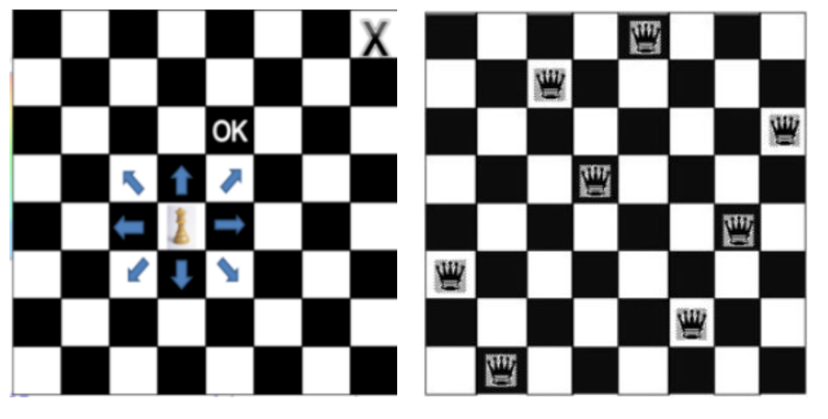

Algorithm of implementation of 8 Queen problem
function Genetic-Algorithm( population, Fitness-fn) returns an individual
inputs: population -> set of individuals
Fitness-fn -> a function that measures the fitness of an individual

repeat
parents <-- Select parents from Population
population <-- Offsprings created by parents

repeat until desired fit individual is obtained

return the best individual in the population

To implement this in Python:irst we import out package numpy and sys

import numpy as np

import sys

Then we will initialize some stopping criteria and parameters

nQueens = 8

STOP_CTR = 28

MUTATE = 0.000001

MUTATE_FLAG = True

MAX_ITER = 100000

POPULATION = None

Initialization phase:

First we will generate the population of board positions
def generateChromosome():
# randomly generates a sequence of board states.
global nQueens
init_distribution = np.arange(nQueens)
np.random.shuffle(init_distribution)
return init_distribution
def generatePopulation(population_size = 100):
global POPULATION
POPULATION = population_size
population = [BoardPosition() for i in range(population_size)]
for i in range(population_size):
population[i].setSequence(generateChromosome())
population[i].setFitness(fitness(population[i].sequence))
print(population[i].sequence)
print(population[i].fitness)
return population

Then we will check against some stop criteria
def stop():
globals()
# print population[0], " printing population[0]"
fitnessvals = [pos.fitness for pos in population]
if STOP_CTR in fitnessvals:
print('here')
return True
if MAX_ITER == iteration:
print('here2')
return True
return False

To determine fitness:
def fitness(chromosome = None):
row_col_clashes = abs(len(chromosome) - len(np.unique(chromosome)))
clashes += row_col_clashes
# calculate diagonal clashes
for i in range(len(chromosome)):
for j in range(len(chromosome)):
if ( i != j):
dx = abs(i-j)
dy = abs(chromosome[i] - chromosome[j])
if(dx == dy):
clashes += 1
return 28 - clashes

For complete code , access the text file provided with the lab manual.

Please refer below link to get complete documentation of code

http://kushalvyas.github.io/gen_8Q.html
LAB EXERCISE:
Q1- import package SciPy and implement 2 code examples illustrating usage of three different functions of this package
Q2- Implement and understand 8 – Queen Algorithm and code.
You can follow description of 8 – Queen Problem code from here:

http://kushalvyas.github.io/gen_8Q.html
Learning Outcomes:
In this lab we implement implement 8 queen problem in Python.

Also we how to import package in Python.

